Q1 We have a dataset of sales of different TV sets across different locations. Records look like: Samsung|Optima|14|Madhya Pradesh|132401|14200 The fields are arranged like: Company Name|Product Name|Size in inches|State|Pin Code|Price sales_differentTV :

There are some invalid records which contain 'NA' in either Company Name or Product Name. Sales of different TV Task 1:

Write a MapReduce program to filter out the invalid records. The output of this program will act as input for subsequent tasks. Map only job will fit for this context.

A1

**INPUT**

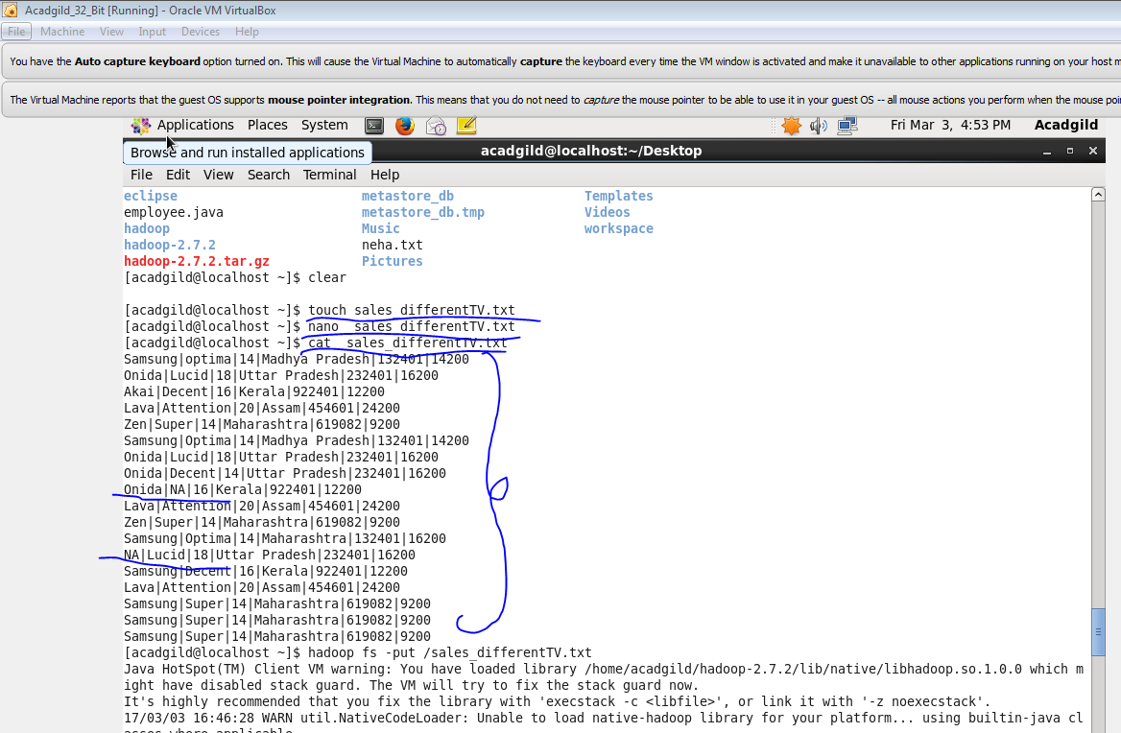

**PROGRAM**

**DRIVER CLASS**

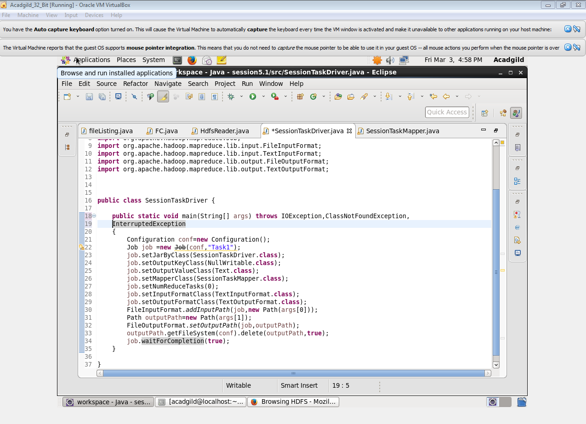

**MAPPER CLASS**

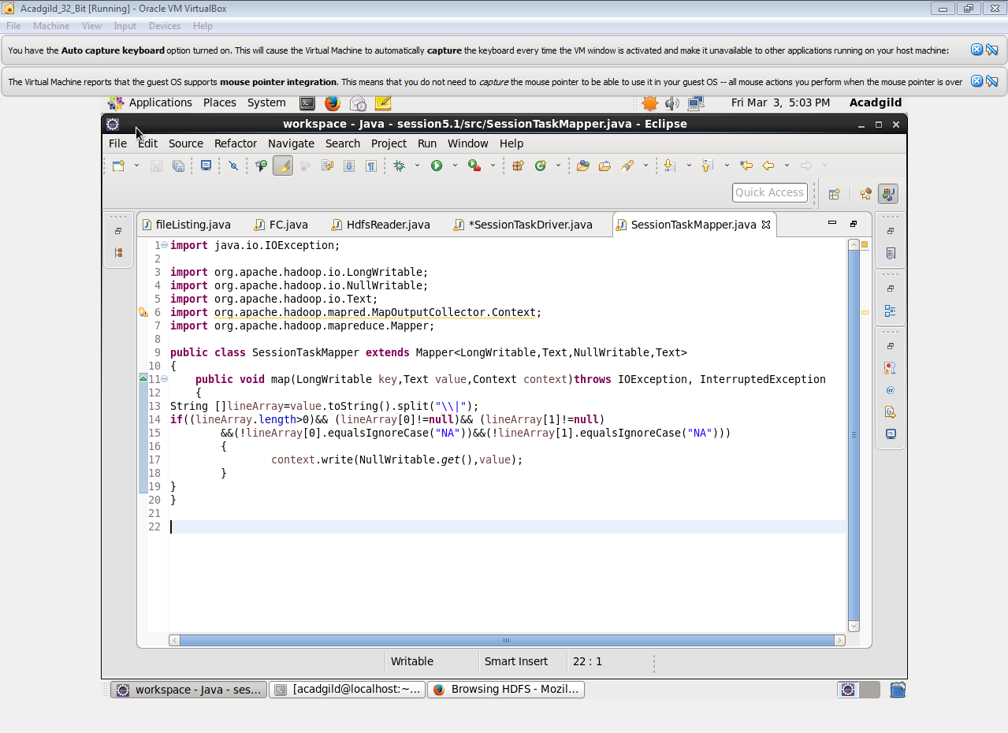

**OUTPUT**

